**ASSIGNMENT**

**GROUP WORK**

**CN 4005: Mental Wealth: Professional Life 1(IT Project Pitching)**

**Submitted By Team ECO TRACE**

Adhithya Vel M V**:** 2668807(Group Leader)

**Corina Petchu:** 2681698

**M Sohaib Ramzan:** 2659471

**Harikaran M:** 2609315

**20243**

Table of Contents

Task 3: Eco Trace 3

Business Proposal 3

Task 4: 6

Presentation Slides 6

Task 5: IT Innovation Report 6

Proposal 6

# Task 3: Eco Trace

## Business Proposal

**Our Aim:**

EcoTrace – a pioneering carbon footprint tracking app aims to revolutionize sustainability practices. EcoTrace empowers individuals and businesses by providing a powerful tool to help them monitor, analyse, and decrease their carbon footprint. But it is not just a simple application; it serves as a driving force for advantageous transformations. Our goal is to provide users with information and useful resources to encourage environmentally-friendly choices that support a more sustainable and environmentally friendly future.

**Overview:**

We aimed to develop a Carbon Footprint app that aims to empower individuals in making sensible choices and reduce their environmental impact. This app will promote sustainable behaviours, raise consciousness, and help achieve the UK's goal of net-zero carbon emissions by 2050 (BBC 2019). On an individual level, individuals underestimate the significance of their small actions on climate change. Insufficient knowledge and awareness hinder collaborative efforts to decrease carbon footprints. Our app aims to address this by providing accessible information and motivating behaviour change.

The app will feature an intuitive interface that allows users to input and track their daily activities, energy consumption, transportation choices and more. It generates personalized reports with actionable insights and eco-friendly alternatives. Leveraging computer vision technology, EcoTrace analyses unstructured data to create structured knowledge bases, offering users visualizations of their carbon footprint impact and guidance for reduction. These knowledge bases will provide users with personalized recommendations and will be able to visualize the direct impact of their choices and implement changes to reduce their carbon footprint.

Key Features:

* User-friendly interface for easy data input and tracking.
* Real-time carbon footprint calculations and visualizations.
* Personalized reports with actionable insights and recommendations.
* Integration with IoT devices for automated data collection.

**Cost/Resource Requirement:**

Our initial year would require an estimated investment of £300,000. The breakdown is as follows:

* Development Costs
  + **App Development**: £40,000i- £120,000
  + **Server Infrastructure**: £5,000 - £15,000
  + **Testing and Quality Assurance**:i£5,000 - £20,000
* Maintenance Cost
  + **Regular Updates**: Continuously improving functionality £10,000 - £30,000
  + **Security Measures**: Protecting user data £5,000 - £15,000
  + **Server Maintenance**: £2,000 - £8,000
* Data Integration
  + **Carbon Footprint Data**: £5,000 - £20,000.
  + **User Data**: £2,000 - £8,000 per year.
* Marketing:
  + **Promotion**: £10,000 - £50,000
  + **Content Creation**: £5,000 - £15,000 per year

**Conclusion:**

EcoTrace represents more than simply a mobile application - it symbolizes a shift towards a future that is both sustainable and healthy. By investing in EcoTrace, you are not only purchasing a technology, but also supporting a change in the way things are done. The app aligns with the UK government’s commitment to carbon neutrality. By empowering individuals, encouraging changes and promoting community engagement, we actively contribute to building a sustainable future.

**Team Roles:**

EcoTrace team consists for Adhithya Vel, Corina Petchu, Harikaran Muruganandham, Muhammad Sohaib. This team is led by Adhithya Vel who will take care of the project.

# Task 4:

## Presentation Slides





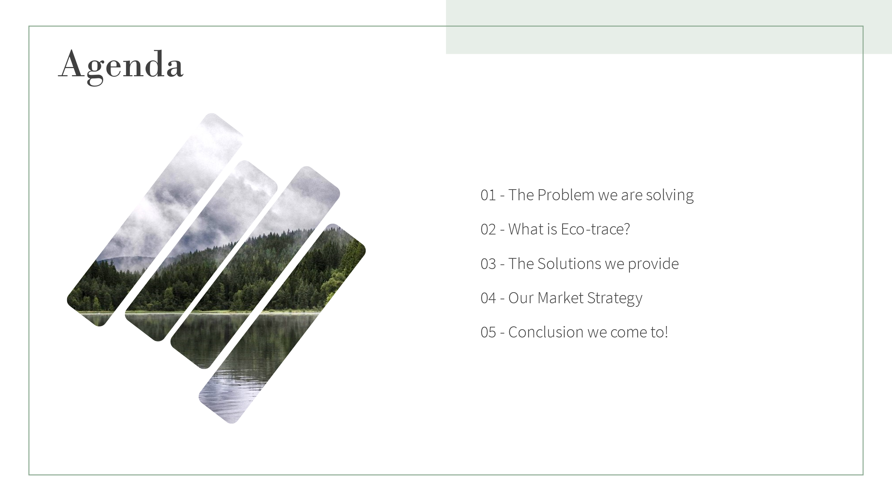

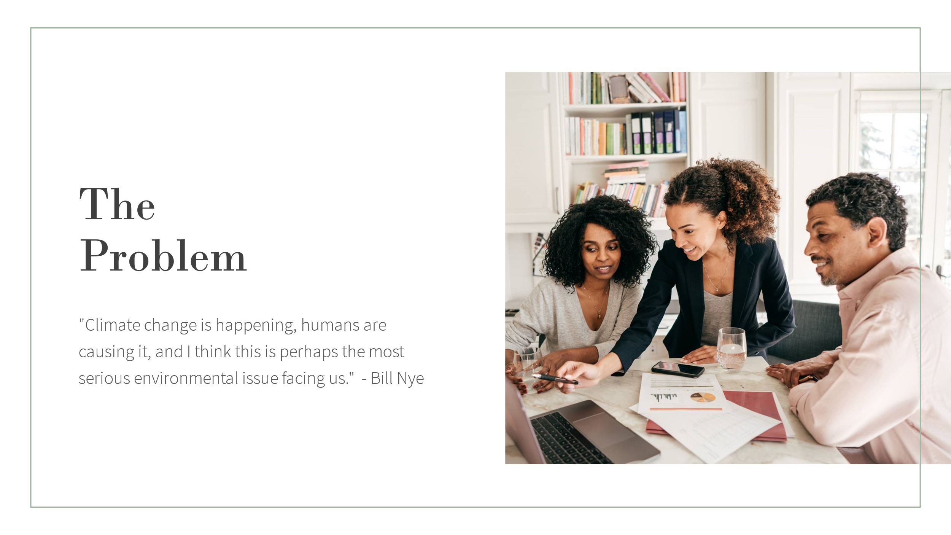

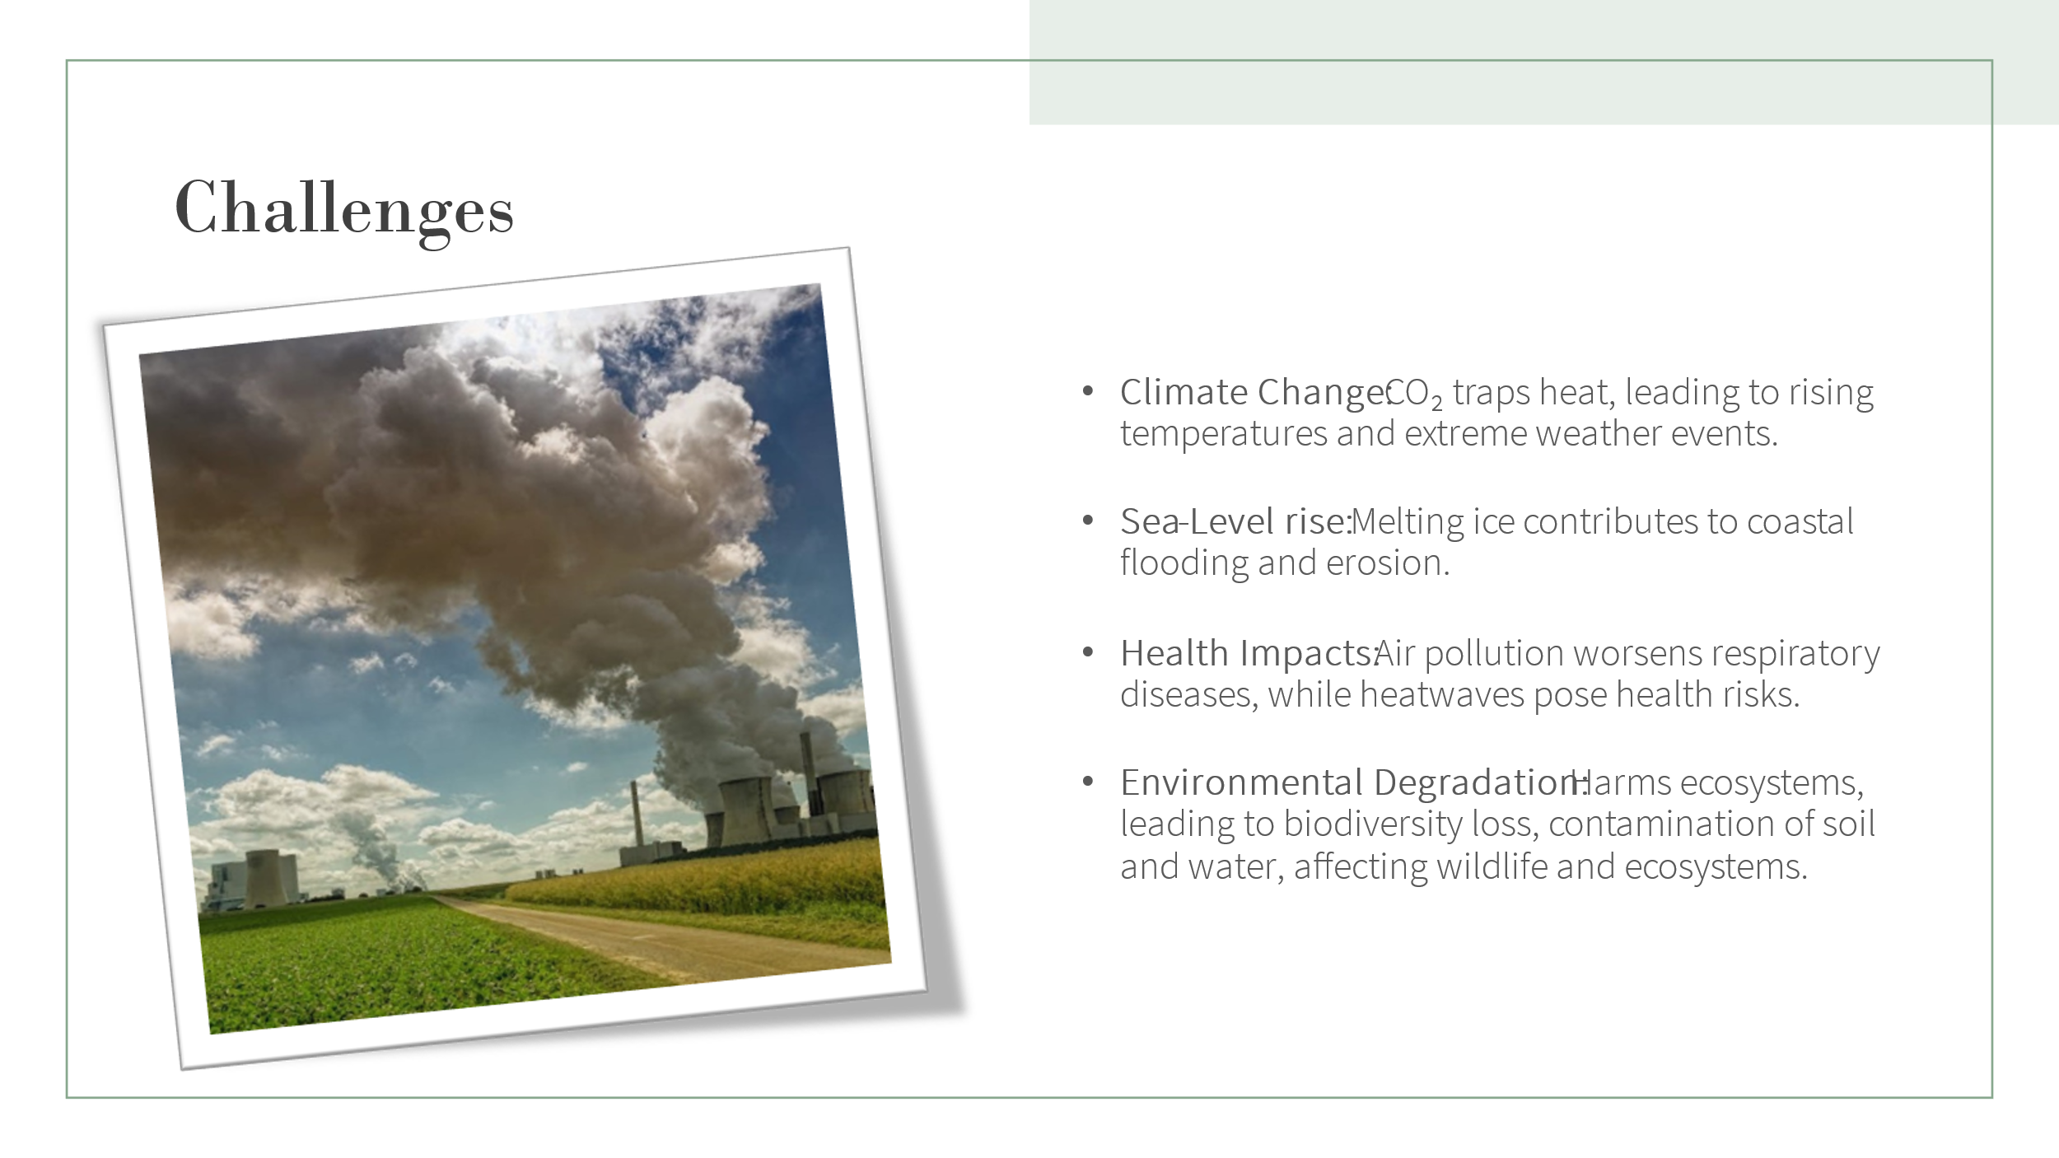

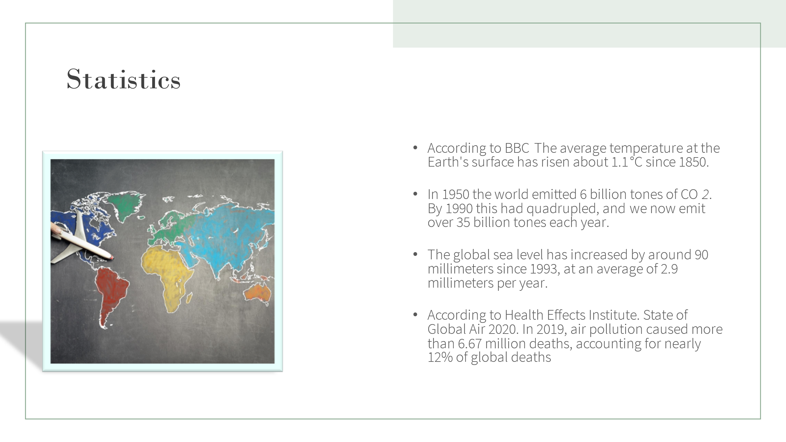

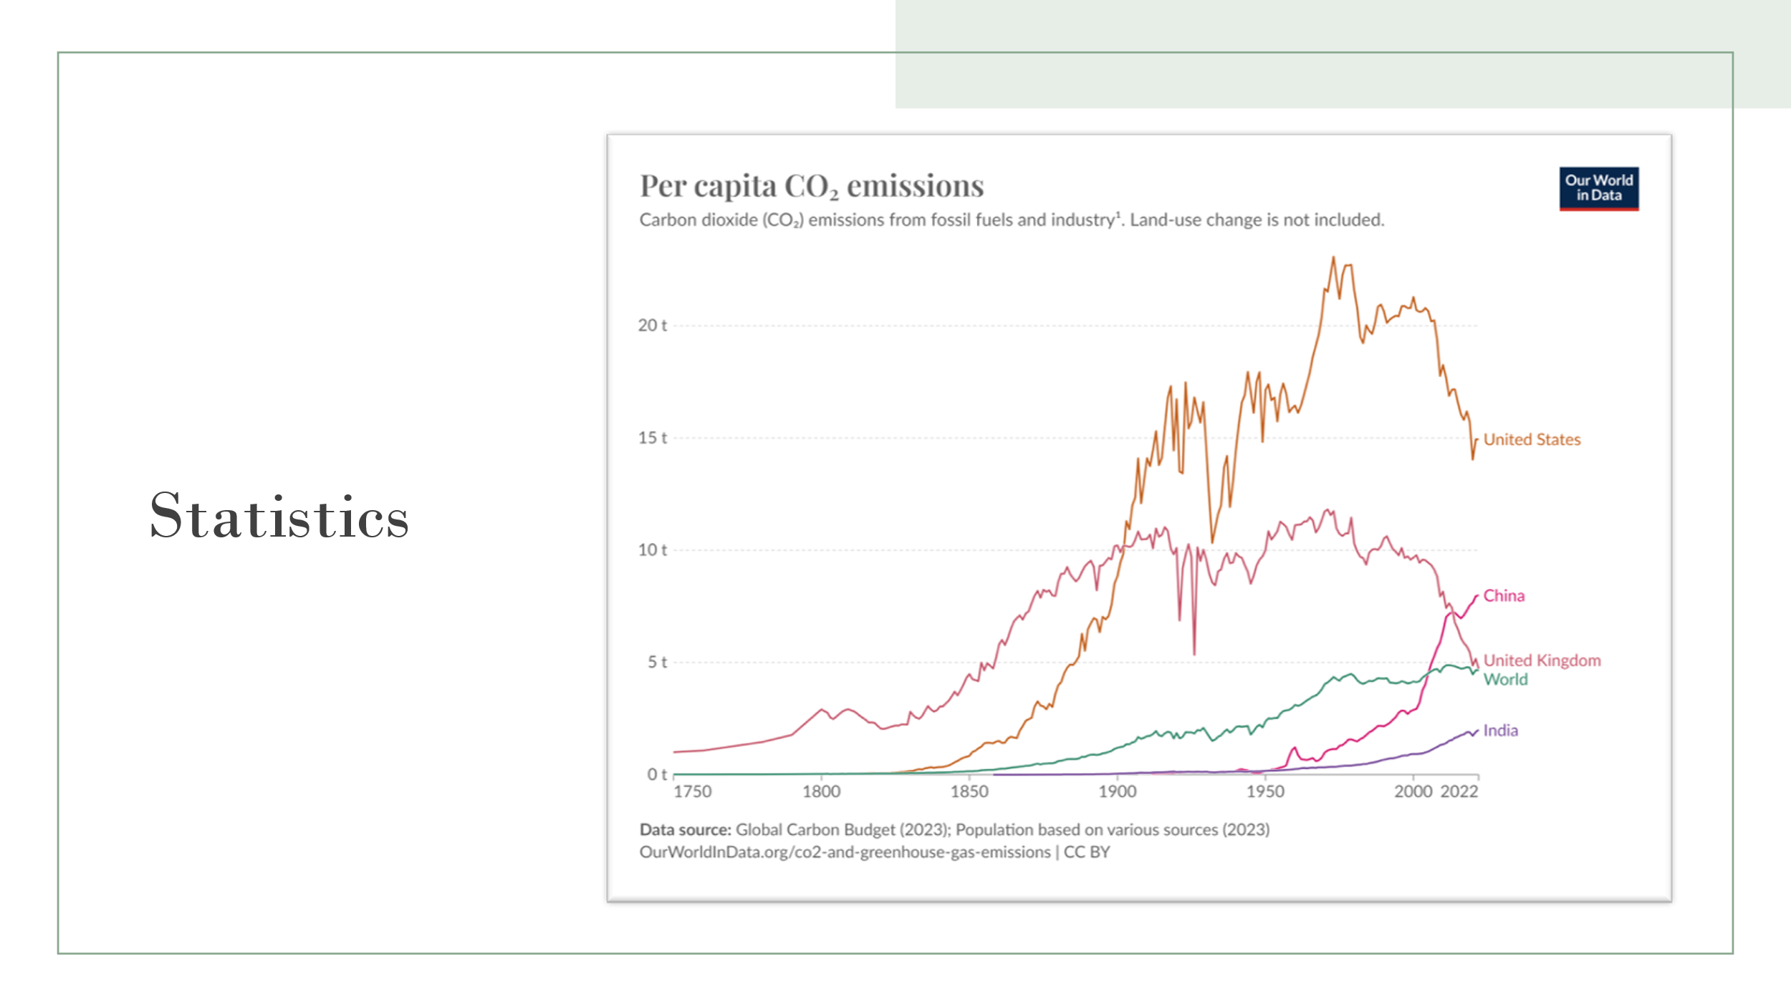

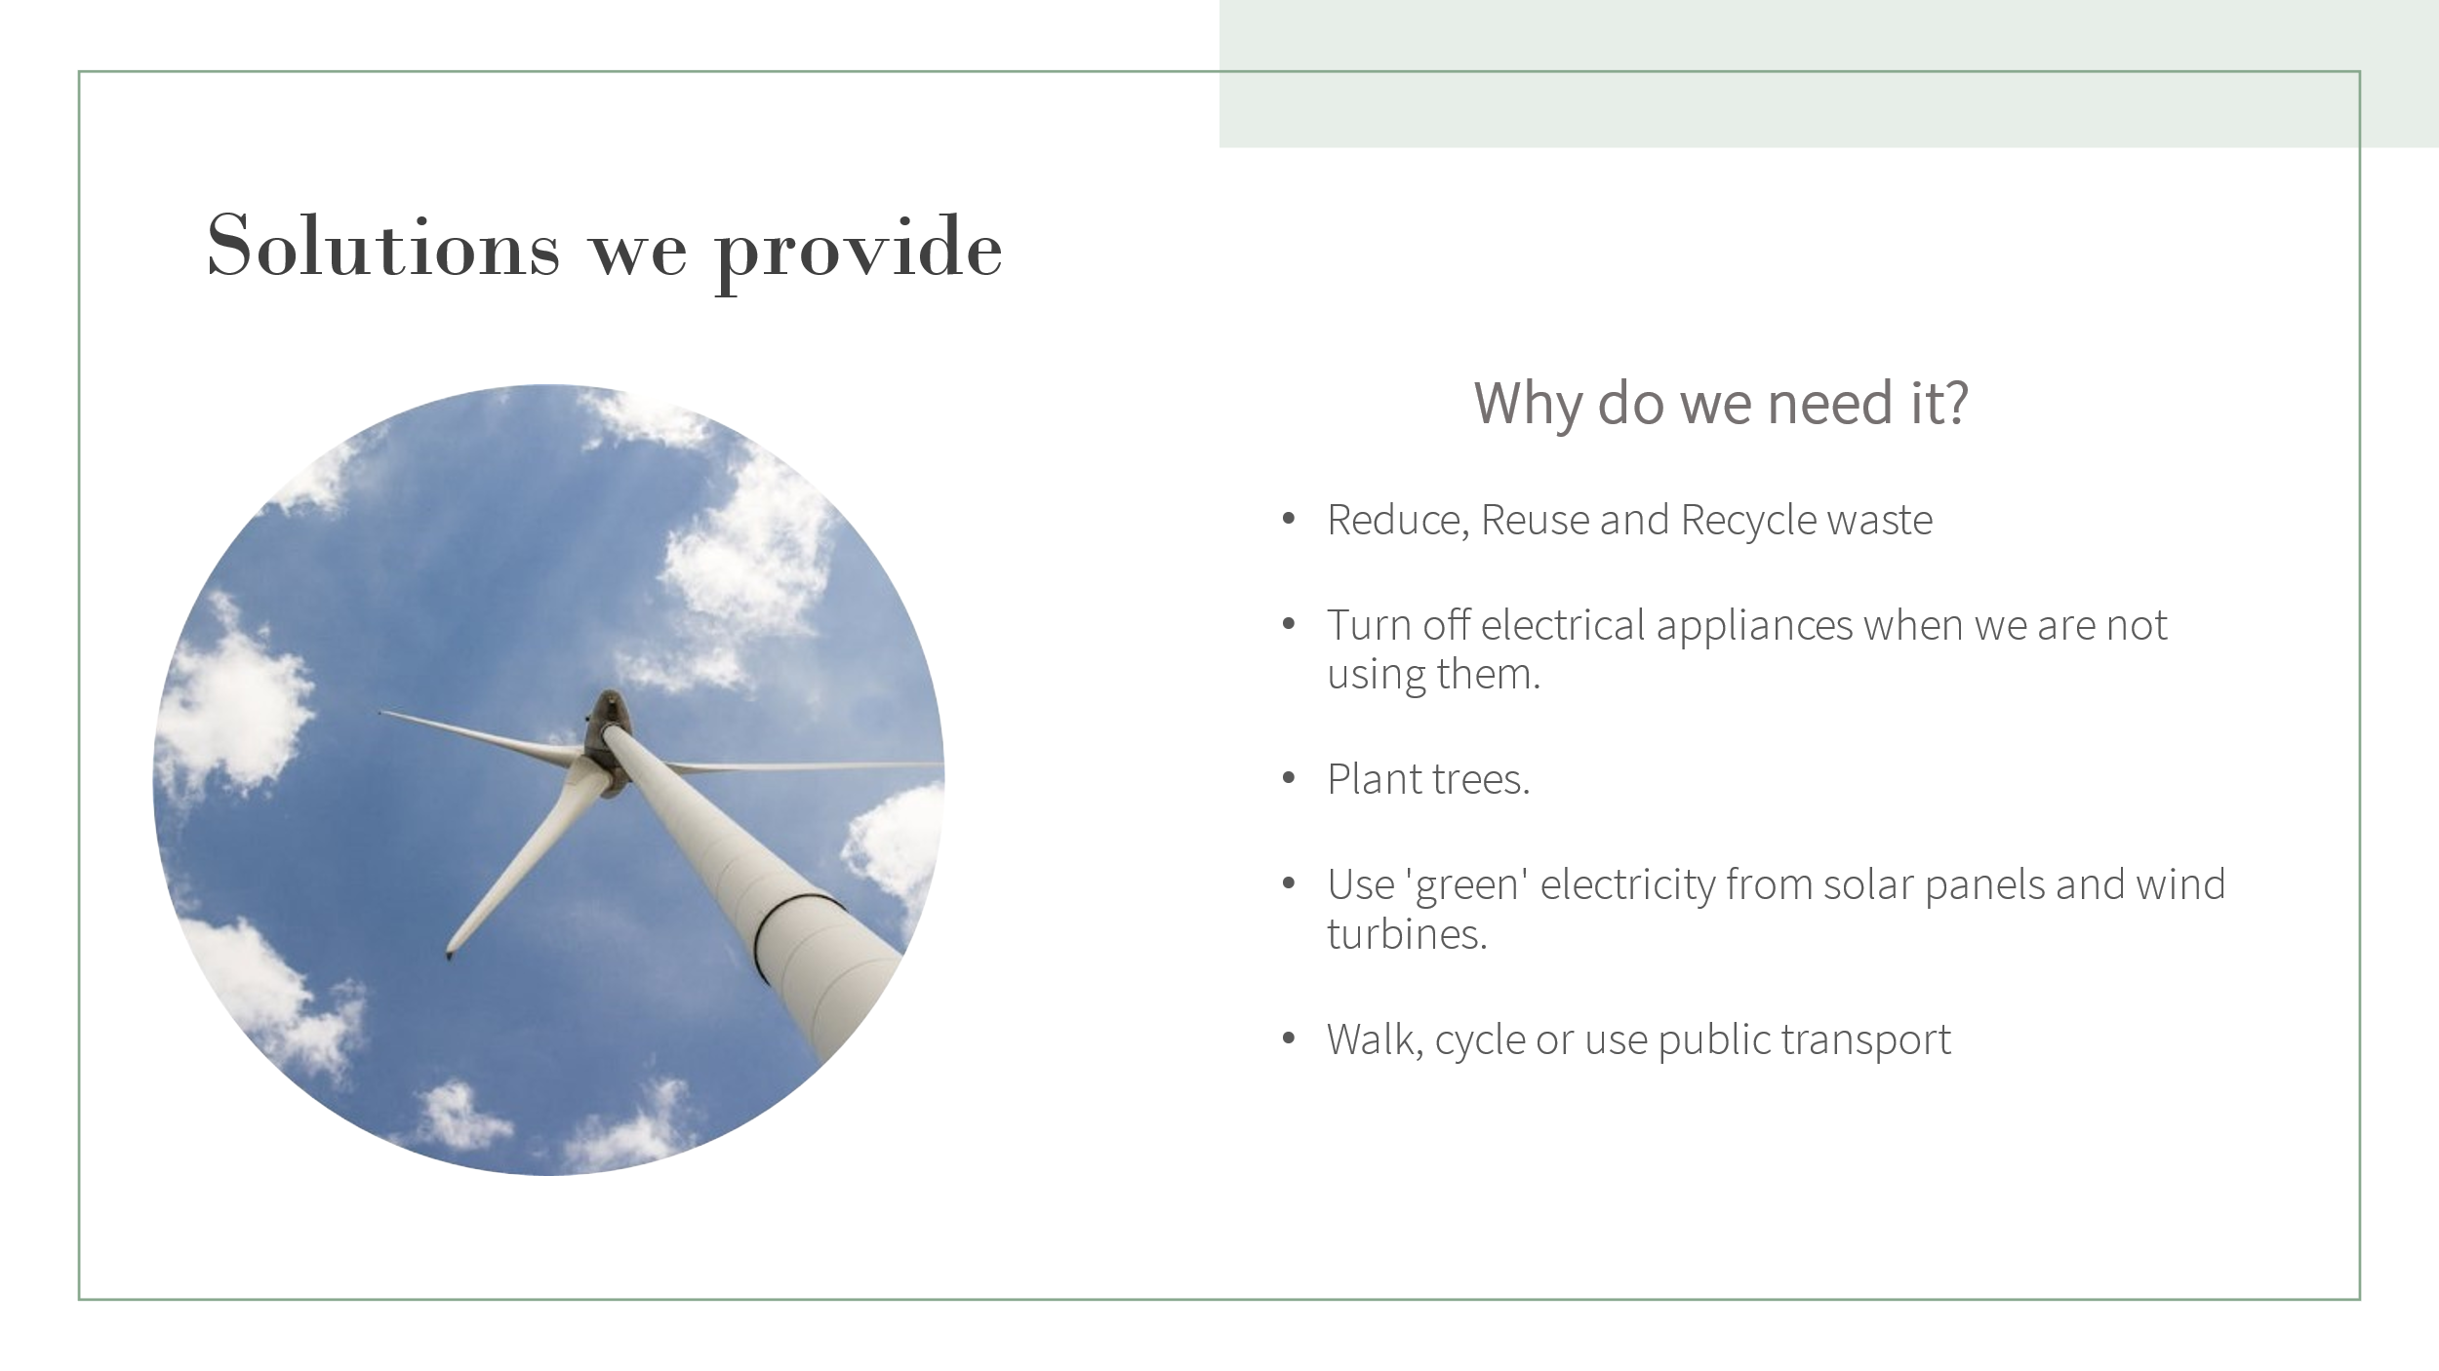

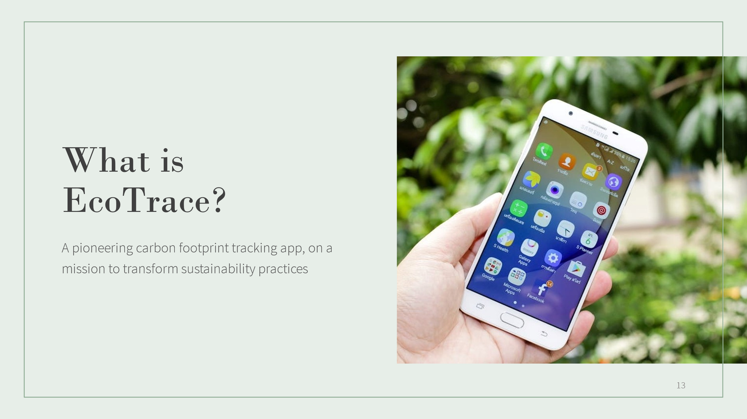

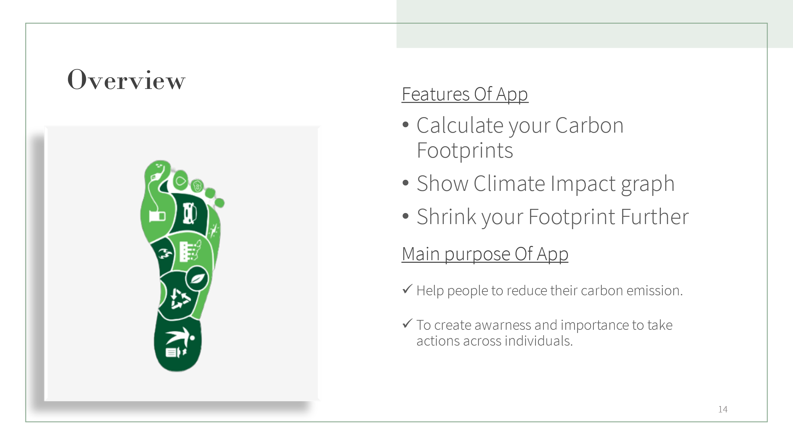

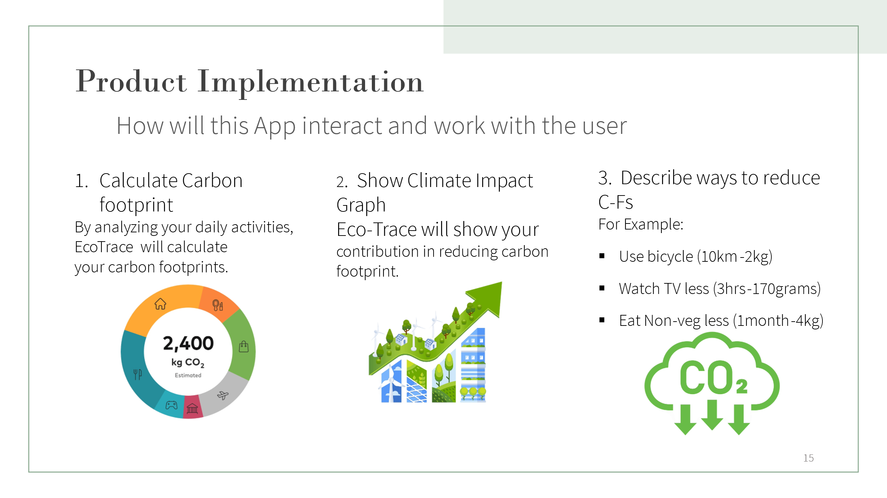



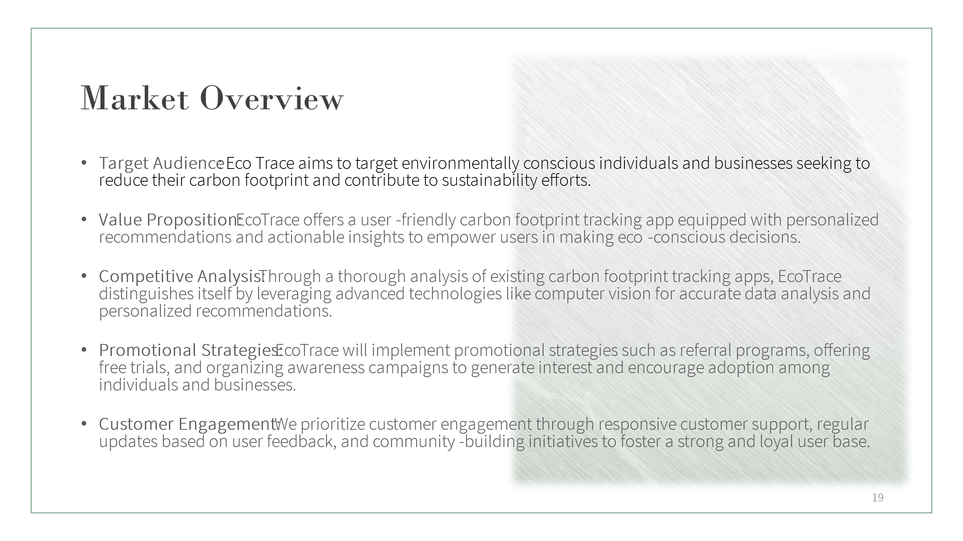

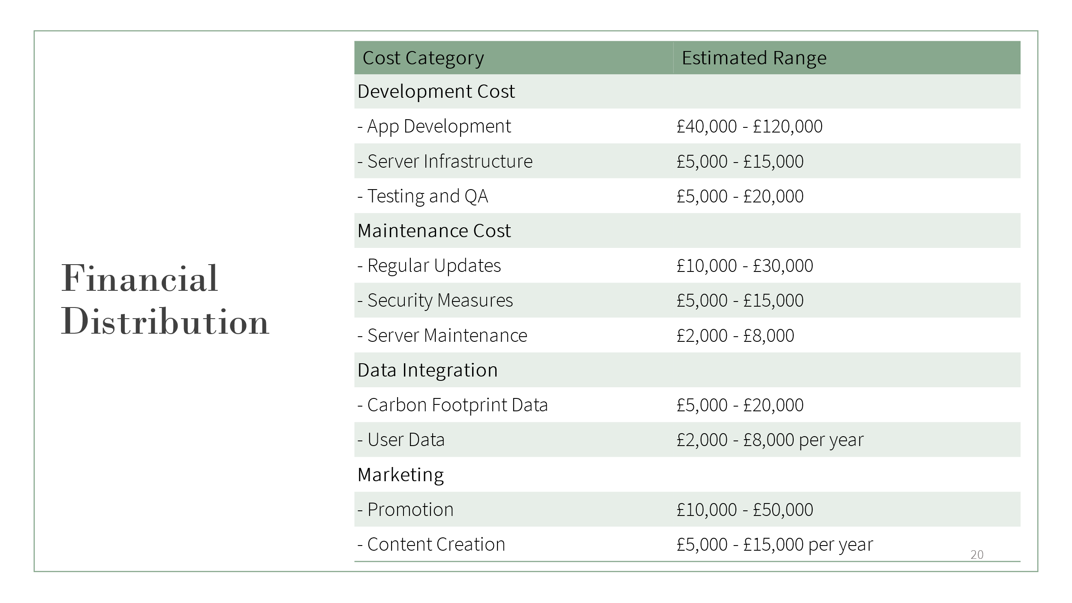

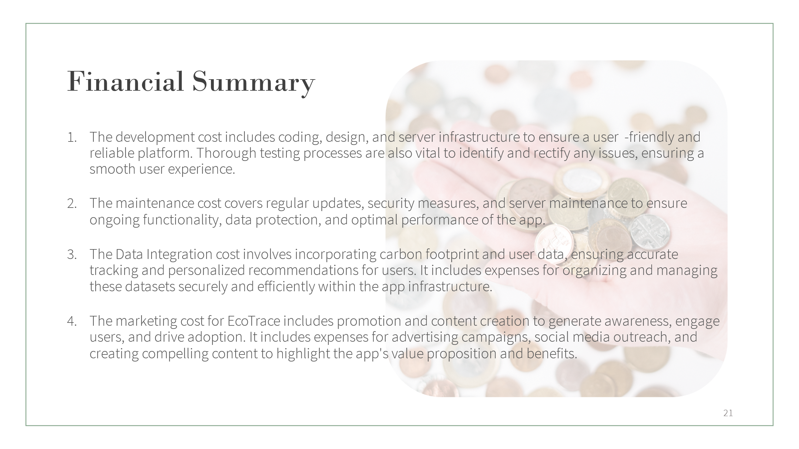

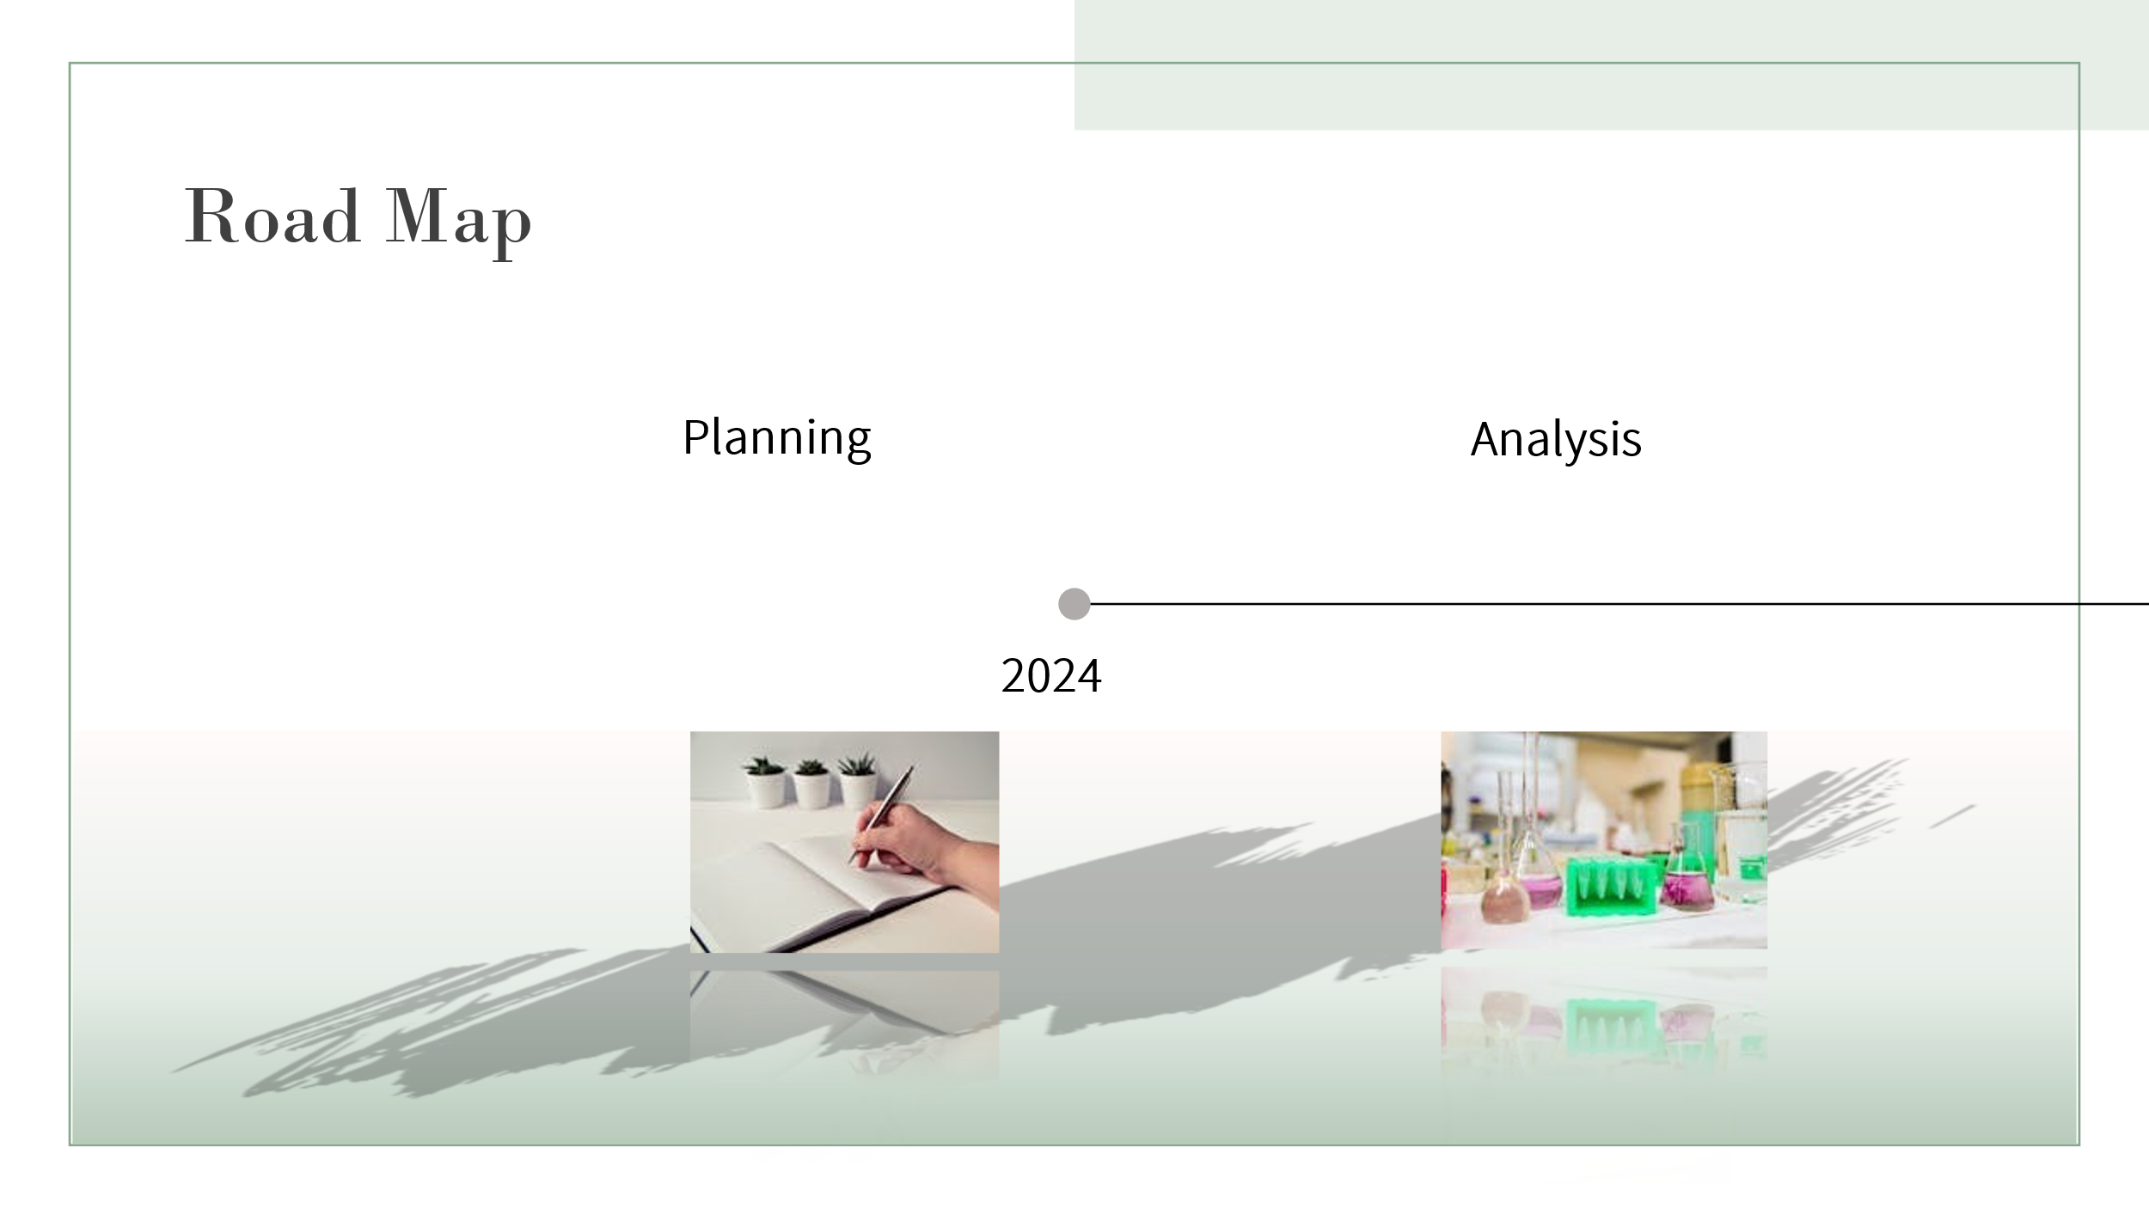

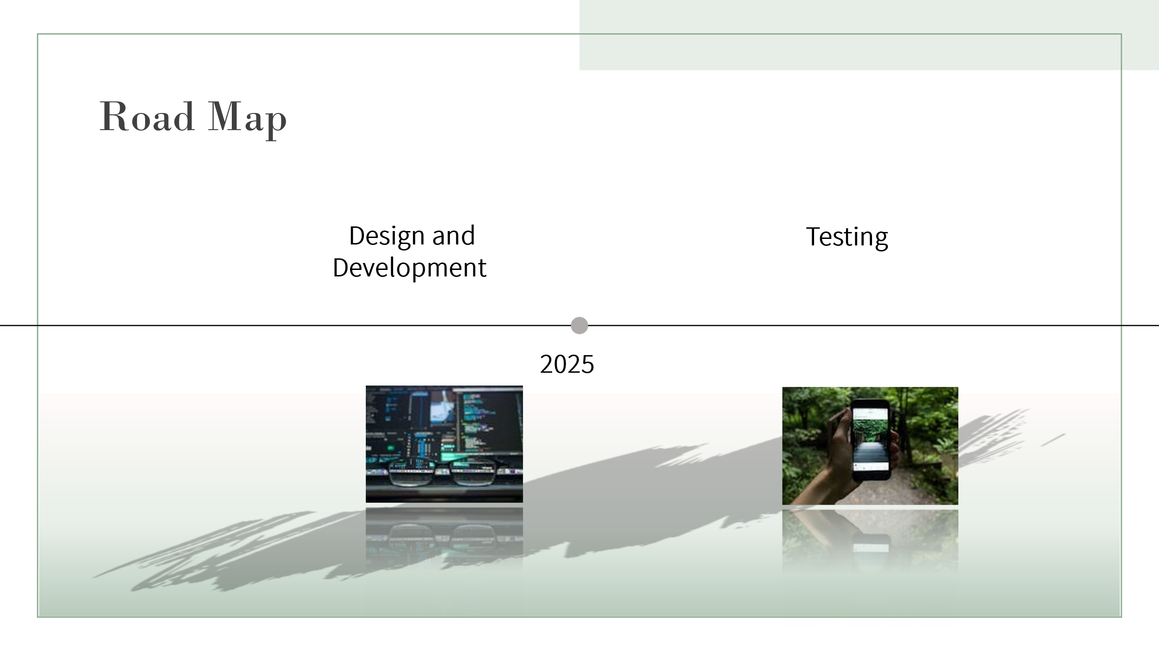

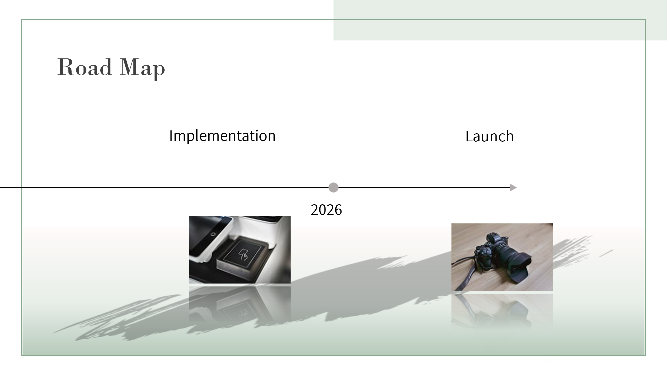



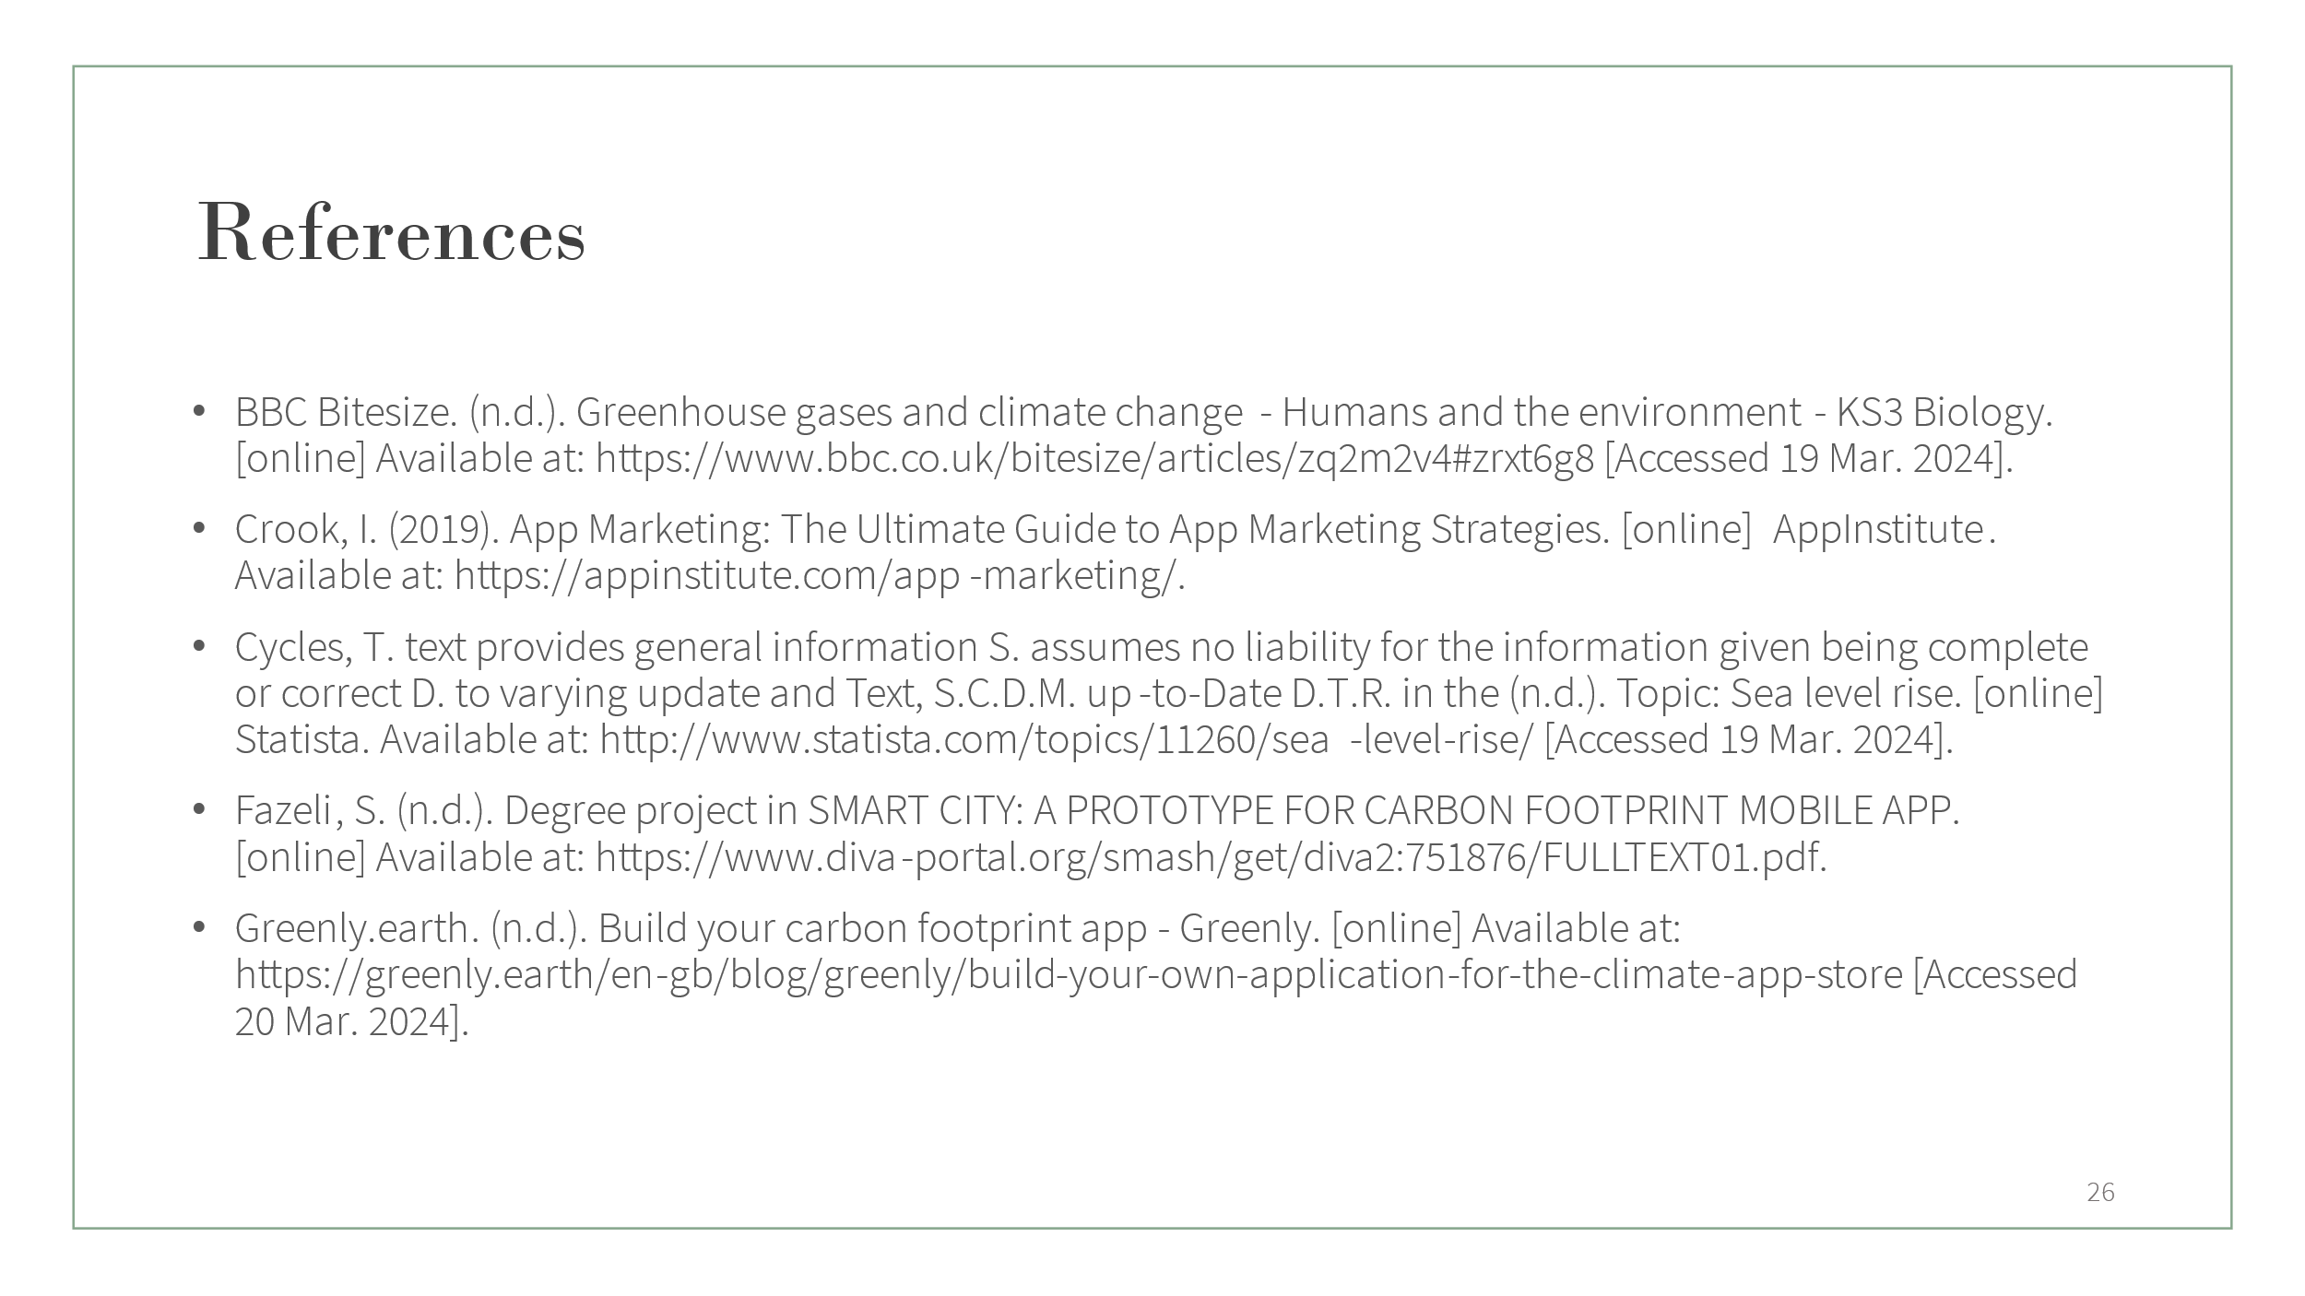

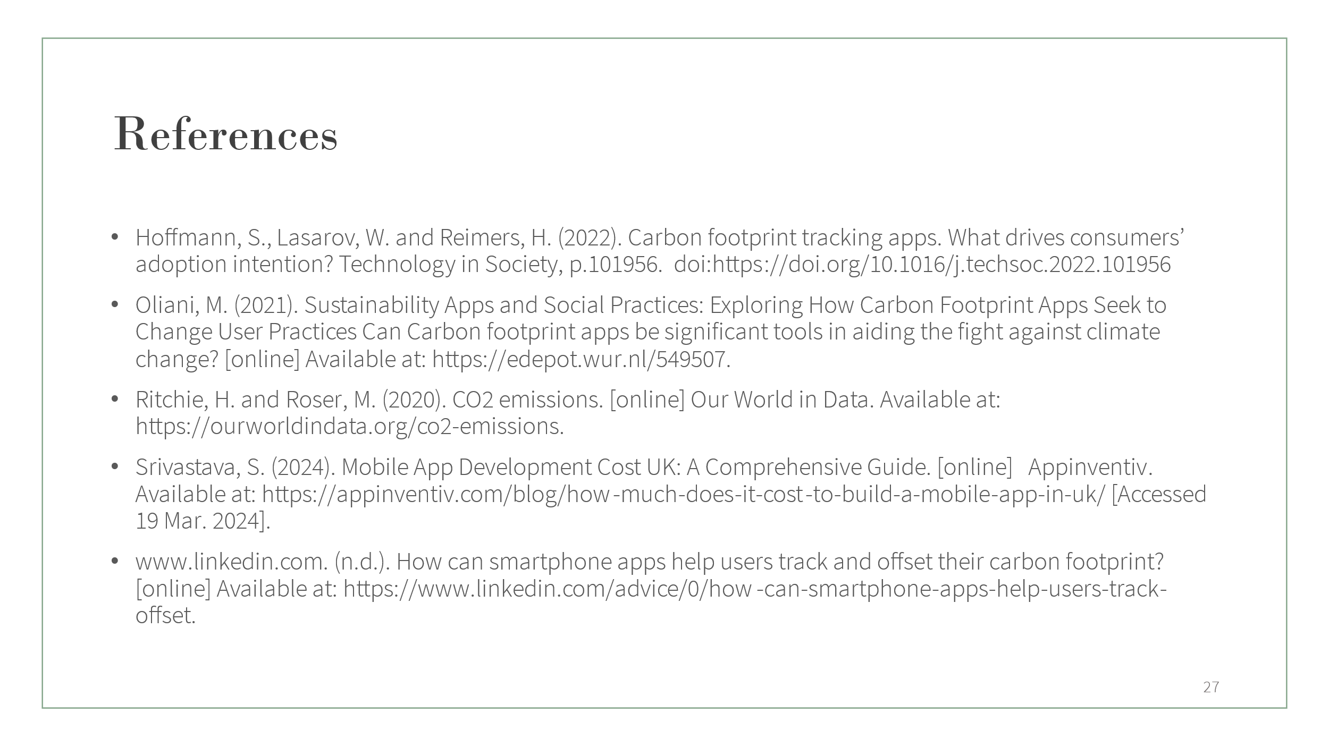 

# Task 5:

### **Table of Contents**

1. Abstract …………………………………………………… 19
2. Introduction ……………………………..……………… 20
3. Literature Review
   1. Main Argument ………………….…………… 21
   2. Review …………………………………………… 21
   3. Solution ………………….……………………… 22
4. Project Methodology
   1. Main Idea ………………….…………………… 23
   2. Research ………………….………………..…… 23
   3. Challenges …………..….……………………… 25
   4. Solution ………………….……………………… 25
   5. Execution ……………….……………………… 25
   6. Marketing plan ………..…………………..… 26
5. Analysis
   1. Impact and Outcome …..…………………… 26
   2. Results ………………….………………………... 26
   3. Issues ………………….………………………..… 27
   4. Future directions ……………………………… 28
6. Conclusion ………………..……….……………………… 28
7. References ………………………….……………………… 29

**ABSTRACT**

Climate change, it is one of the most important and challenging issues facing humanity. The rise in global temperatures, rising sea levels are some issues leading to several dangerous and irreversible impacts on economies and societies.

One such threats to the living beings on Earth is the Global Warming, which has increased significantly over the past decades. Human factors are the primary reason for the contribution of carbon dioxide; primary greenhouse gas in development of global warming. Greenhouse gas emissions and, in particular, carbon dioxide emissions are growing significantly to the extent that if no initiatives are taken, it can poses threats for our future generations and in general for anyone’s life on Earth, therefore we need means by which we can control and maintain the levels of greenhouse gas emissions.

One of the efficient solutions that can significantly decrease the levels of carbon dioxide emissions is the construction and development of sustainable and eco-friendly practices in various fields. In this context, we focus on individual level, where they can play an important role in reducing the CO2 emissions.

By considering the new opportunities that can help in reducing CO2 emissions, this report tries to introduce the idea of a self-tracking Carbon Footprint mobile application which enables users to keep track of their individual’s carbon dioxide emissions occurred as a result of their daily activities such as eating, transportation, shopping, energy consumption, and etc. in real time.

With the awareness and being able to measure the generated carbon footprint of the user’s activities, users will be able to monitor and control it. This monitoring and controlling of one’s carbon footprint can have significant influences in reducing CO2 emissions.

**INTRODUCTION**

Climate change poses significant challenges to our global environment, influencing everything from biodiversity to human well-being. As global temperatures rise and weather patterns become increasingly unpredictable, efforts to mitigate the impacts of climate change have become crucial.

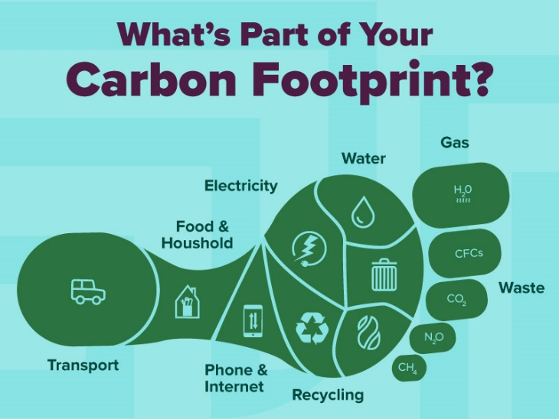

Image1: This is an illustrated image of a foot contains of a person or organizations carbon footprints.

According to Maslin (2004), “The Earth’s atmosphere is composed of 78% nitrogen, 21% oxygen, and 1% other gases. It is these other gases that we are interested in, as they include the so-called greenhouse gases.” He further explains that the two most main greenhouse gases are carbon dioxide and water vapour, which “carbon dioxide accounts for 0.03-0.04 % of the atmosphere” Maslin (2004). As Maslin states in his book, the rise in atmospheric carbon dioxide has started since the beginning of industrial revolution where the first measurement of CO2 concentration in atmosphere started in 1958 and since then the level of CO2 concentrations have increased every single year.

Proper initiatives to reduce CO2 emissions must be taken, otherwise there would be serious consequences which can endanger human’s life on Earth. The use of technology, such as mobile applications focused on reducing carbon footprints, has emerged as a promising tool in this area. These apps aim to inform and influence individual behaviour changes towards sustainability, representing a novel intersection of technology and environmental science.

**LITERATURE REVIEW**

**Main Argument-**

Adoption of carbon footprint reduction applications is motivated by the pressing need to involve people in climate action by easily accessible and useful methods. These applications give people a direct approach to comprehend and control their environmental effect, unlike conventional approaches that might need complicated calculations and little user involvement.

The primary thesis of this review of the research is that, although carbon footprint apps are a useful tool for encouraging sustainable activities, their efficacy is greatly impacted by design elements, user interaction techniques, and integration with current digital habits.

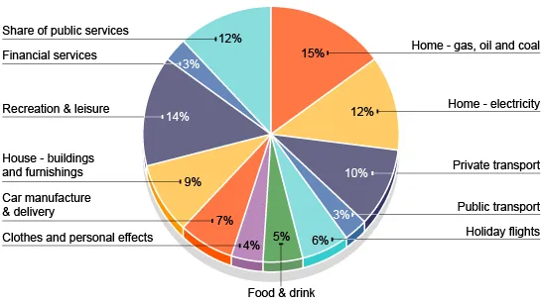

Figure1: Pie Chart showing a breakdown of a carbon footprint by various industries in a MEDC

**Reviewing Other Authors' Work-**

Brauer et al. (2016) discuss the potential of mobile applications to facilitate sustainable behaviour changes. Their insights into user accessibility and interaction offer a foundational understanding of how apps can serve as effective tools for environmental engagement.

Dreijerink & Paradies (2020) review the effectiveness of carbon footprint apps, pointing out the lack of broad research in this area and the mixed results of app effectiveness based on health intervention studies

Gomes et al. (2019) and Williams et al. (2019) demonstrate the direct consequences of climate change on ecosystems and human activities, such as increased wildfire incidents and threats to species, underlining the immediate need for action.

Salo et al. (2019) identify both the opportunities and limitations of carbon footprint calculators. They suggest that portability and repeated use are essential for success, which traditional web-based calculators often lack.

Sippel et al. (2020) highlight the measurable impacts of climate change on daily global temperature and moisture, providing a data-driven rationale for why everyday actions matter in the broader climate context.

Research by Kisurina (2017) and Reick (2020) provides case studies on specific apps, highlighting how gamification and user-focused design can enhance engagement and effectiveness.

**Proving Our Solution by Comparing it to Other Authors-**

The literature presents a fragmented picture of the effectiveness of carbon footprint reduction apps. While these tools are promising, their success varies based on several factors:

User Engagement and Interface Design: As shown by Kisurina (2017) and Reick (2020), apps that use gamification and offer user-friendly interfaces tend to engage users more effectively. This engagement is crucial for fostering long-term behavioural change, a point also supported by Salo et al (2019) who noted the importance of making apps usable more than once.

Integration with Existing Digital Ecosystems: According to Mu et al (2019), users prefer apps that integrate seamlessly with their existing digital habits. Apps that require less behavioural shift are more likely to be adopted and sustained.

Real-time Feedback and Personalization: Drawing on findings from health behaviour applications, Zhao et al (2015) emphasize that apps providing real-time feedback and personalized experiences are more likely to achieve sustained user engagement and behaviour change.

**Our proposed solution builds on these findings by focusing on three key areas-**

Improving User Involvement: We can raise user satisfaction and retention by adding interactive elements and gamification that reward sustainable decisions.

Easy Integration: To make our software more useful and to lower the entrance barrier for new users, it will interface with commonly used platforms and services.

Adaptive Learning and Personalization: The app will take use of machine learning algorithms to adjust to user preferences and offer customized comments and suggestions, therefore addressing the individualized aspect of sustainable behaviours as recommended by the body of current research.

**Project Methodology**

**Conception/Main Idea-**

EcoTrace is a tool designed to track, analyse, and reduce carbon footprints; it aims to revolutionize sustainability practices. Its goal is to enable people and companies to make environmentally responsible choices and help create a more sustainable future.

The application boasts a user-friendly interface for monitoring daily routines, energy usage, transportation decisions, and more. It utilizes computer vision technology to analyse information and offer customized suggestions for mitigating carbon emissions.

**Research-**

By defining carbon footprint; It is the total amount of greenhouse gas emissions produced by a person, group, happening, or item, both directly and indirectly, we can understand where carbon emissions are playing a role.

Identifying market gaps and opportunities through comprehensive analysis of existing carbon footprint tracking solutions.

In a report written by Carlsson-Kanyama et al (2007), the calculated emissions per capita in Sweden are more likely to be between 6.8 and 12 tons CO2.

Khalil et al (2007) explains Methane, for example, is 23 times stronger than CO2 , which means that 1 ton of methane corresponds to 23 tons of CO2 equivalents.

In urban transformation, urban industrial symbiosis can reduce the carbon footprint and accelerate the transformation toward lowering carbon emissions in urban areas (Fang et al. 2017).

Evaluating the viability of leveraging computer vision technology for data analysis and assessing API availability. Studying competitors' offerings to identify areas for differentiation and improvement.

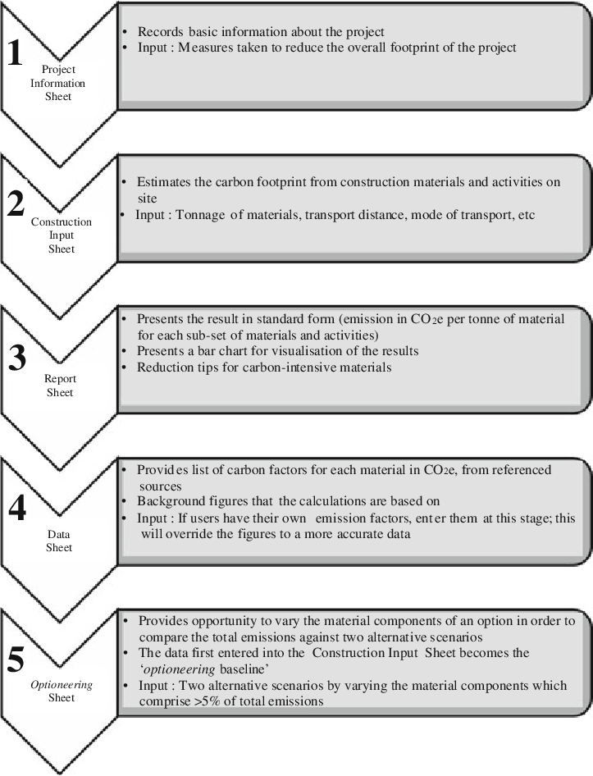

Figure2: Methodology of carbon footprint calculation

**Challenges-**

One of the biggest obstacles was raising the $300,000 initial investment needed for server setup, app development, marketing, and operating costs.

Achieving a balance between the number of features and development costs required careful budget allocation and prioritization.

The financial burden was increased by ongoing expenses for server maintenance, security measures, and updates.

Integrating real-time carbon footprint data and guaranteeing secure user data management presented challenges.

**Solution-**

EcoTrace provides a complete carbon footprint tracking solution along with customized insights and useful suggestions.

Real-time carbon footprint estimates, customized reports, connectivity with Internet of Things devices, and data visualisation are among the salient characteristics.

With the app, users will be able to make more informed decisions and effectively reduce their carbon footprint by implementing changes.

**Executions-**

App development, server infrastructure setup, testing, and quality assurance are all included in development costs.

Regular updates, security precautions, server upkeep, and data integration are all included in maintenance costs.

Integrating data entails managing user information, integrating carbon footprint data, and gaining access to third-party APIs.

In order to guarantee seamless operation and user satisfaction, implementation demands meticulous planning and execution.

**Marketing Plan-**

Promotional activities, content creation, and user acquisition are all part of marketing efforts.

Marketing budget allocation covers advertising, influencer partnerships, social media promotion, and content production costs.

The marketing plan seeks to draw in users, make the app more visible, and position EcoTrace as a front-runner in the sustainability market.

**Analysis**

**Impact and Outcome-**

The implementation of the carbon footprint tracking app has resulted in significant positive outcomes and impacts:

Increased Awareness: The app was successful in increasing user's knowledge of their personal carbon footprints and the effects that their daily actions have on the environment.

Behaviour Change: After using the app, a decent part of users claimed to have started adopting more eco-friendly habits like adjusting dietary preferences, energy consumption patterns, and modes of transportation in order to lower carbon emissions.

Community Engagement: The app created a thriving online community for those for likeminded individuals. By actively participating in challenges, sharing opinions, and commenting users foster a community that encourages sustainable living.

**Results-**

User Engagement and Adoption: The users reported that they used the app during their free time or when taking breaks from chores as they found it inconvenient to use during their work.

Carbon Footprint Tracking Metrics: Data analysis revealed insightful patterns in users' carbon emissions across various activities. Key metrics, such as daily emissions trends and activity-specific breakdowns, provided users with valuable insights into their environmental impact.

Impact on Behaviour Change: Usage of the app emerged as a potential to impact other aspects of the user's life. Users expressed a heightened sense of responsibility towards reducing their carbon footprints.

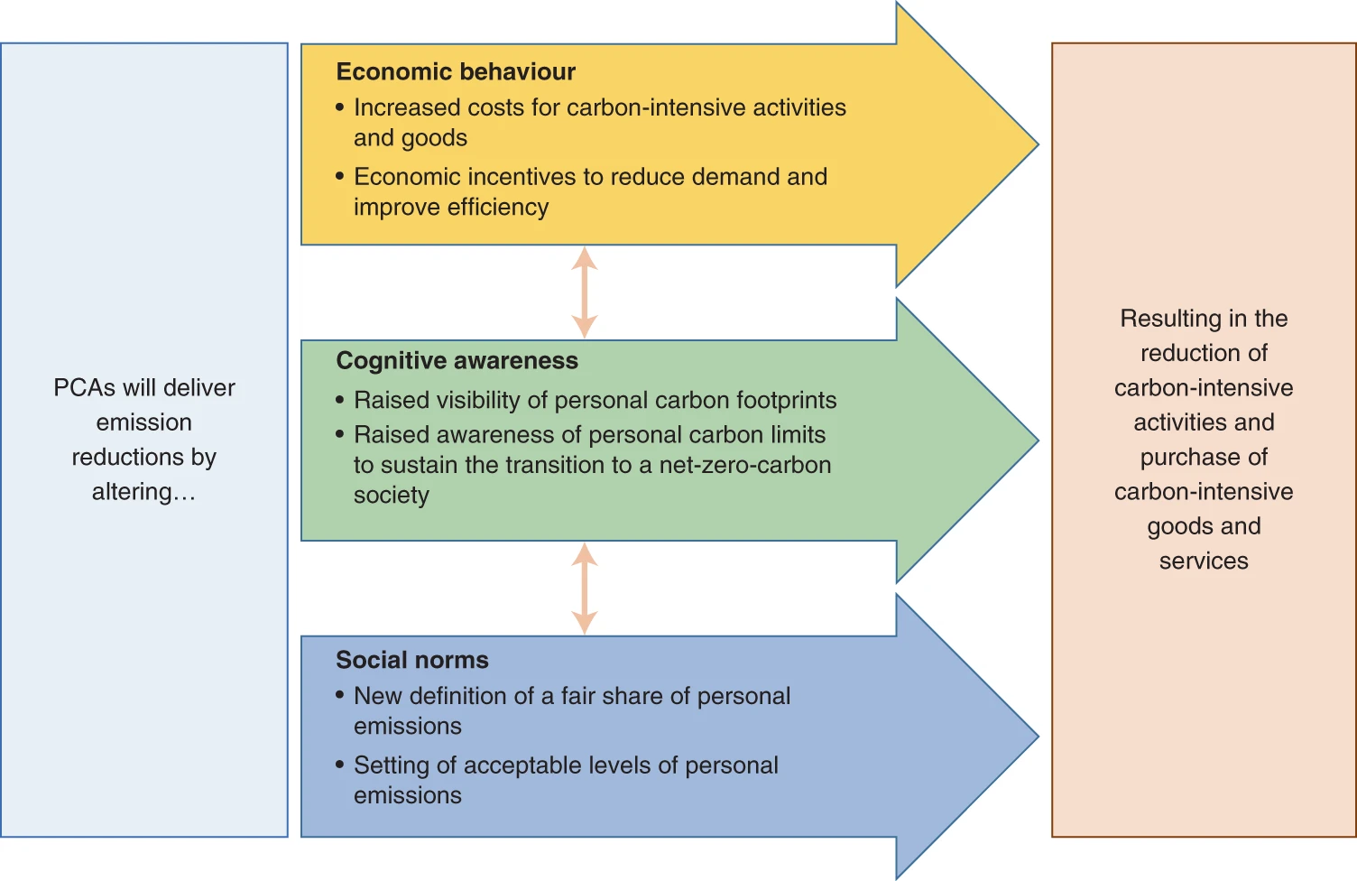

Figure 3: Key Mechanisms by which Personal Carbon Allowances contribute to low carbon foot

**Issues Faced and Challenges-**

Despite the positive outcomes, several challenges were encountered during the app's implementation:

Data Accuracy: Miozzo et al (2021) found out that algorithms used to track emissions like Green algorithms calculated to be higher than those computed by ML CO2 Impact. Hence ensuring the accuracy and reliability of carbon footprint calculations proved challenging.

Technical Issues: Users encountered occasional technical glitches and performance issues, impacting their experience with the app. Continuous optimization and bug fixes are being implemented to enhance app stability.

Behavioural Change Sustainability: During the initial times on using the app, user stays excited and motivated to change actions, but over the long run these engagement come down. Strategies for maintaining user motivation and support are still under evaluation.

**Future Directions-**

Moving forward, efforts will focus on addressing the identified challenges and further enhancing the app's effectiveness in promoting sustainable behaviour change.

Enhanced data integration involves working with data providers to increase the availability and accuracy of carbon footprint data.

User experience optimization involves making iterative changes to the functionality and user interface of the app in order to improve usability and engagement.

Behavioural insights research involves how people act, why they do things and what stops them from changing, and uses this to make specific actions.

**Conclusion**

Climate Change is a complex problem that becomes more pressing for humans every day. Due to its nature as a complex problem, there is also no single solution that can solve it. Rather, it requires a process of adapting effective and sustainable actions in individual lifestyles and the larger governmental and economic systems, this will help mitigate climate change. Human factors are one of the primary reasons that contribute to global warming. As individuals we must take steps to reduce greenhouse gas emissions to mitigate its impacts.

One method to reach individuals rising in popularity with the rise of mobile phones are mobile applications.

Monitoring and controlling one's carbon footprint through activity measurement can significantly reduce human factors contributing to increased carbon dioxide emissions and global warming effects.

In conclusion, applications for reducing carbon footprints have significant potential, but their development and usage need to be guided by multidisciplinary study and customised to the tastes and behaviours of the user. Our solution aims to provide a more effective and sustainable approach to individual climate action by enhancing user involvement, integration, and personalization.

**References**

1. Assessment and Reduction of Carbon Footprint: An Approach via Best Management Practices in a Construction Site - Scientific Figure on ResearchGate. Available from: https://www.researchgate.net/figure/Methodology-of-carbon-footprint-calculation_fig1_280627918 [accessed 5 May, 2024]
2. Bannour, N., Ghannay, S. and Névéol, A. (2021). Evaluating the carbon footprint of NLP methods: a survey and analysis of existing tools. [online] pp.11–21. Available at: <https://aclanthology.org/2021.sustainlp-1.2.pdf>.
3. BBC Bitesize. (n.d.). Greenhouse gases and climate change - Humans and the environment - KS3 Biology. [online] Available at: https://www.bbc.co.uk/bitesize/articles/zq2m2v4#zrxt6g8 [Accessed 19 Mar. 2024].
4. Brauer, B. et al. (2016) Green by App: The contribution of mobile applications to environmental sustainability, AIS Electronic Library (AISeL). Available at: https://aisel.aisnet.org/pacis2016/220/ (Accessed: 06 May 2024).
5. Carlsson-Kanyama A, Assefa G, Peters G and Wadeskog A, 2007. Koldioxidutsläpp till följd av Sveriges export och konsumtion - beräkningar med olika metoder (Carbon dioxid emissions according to Swedish export and consumption – calculations with different methods). KTH, Stockholm. TRITA-IM: 2007:11.
6. Crook, I. (2019). App Marketing: The Ultimate Guide to App Marketing Strategies. [online] AppInstitute. Available at: <https://appinstitute.com/app-marketing/>.
7. Decode6.org. (2024). Available at: <https://decode6.org/wp-content/uploads/2023/04/Carbon-Footprint_01.jpg>.
8. Dreijerink, L.J.M. and Paradies, G.L. (2020) How to reduce individual environmental impact? A literature review into the effects and behavioural change potential of carbon footprint calculators, repository.tno.nl. Available at: https://repository.tno.nl/islandora/object/uuid:82bec847-f0f7-4b83-bcef-af92b255b525 (Accessed: 06 May 2024).
9. Fang, K., Dong, L., Ren, J., Zhang, Q., Han, L. and Fu, H. (2017). Carbon footprints of urban transition: Tracking circular economy promotions in Guiyang, China. Ecological Modelling, 365, pp.30–44. doi:https://doi.org/10.1016/j.ecolmodel.2017.09.024.
10. Fazeli, S. (n.d.). Degree project in SMART CITY: A PROTOTYPE FOR CARBON FOOTPRINT MOBILE APP. [online] Available at: <https://www.diva-portal.org/smash/get/diva2:751876/FULLTEXT01.pdf>.
11. Fig. 1: PCA influence mechanisms for delivering emission reductions. | Nature Sustainability. (n.d.). www.nature.com. [online] Available at: <https://www.nature.com/articles/s41893-021-00756-w/figures/1>.
12. gohchermane2904 (2013). *Carbon footprints*. [online] GEOGRAPHY 7 OMEGA. Available at: <https://omega7geo.wordpress.com/2013/12/11/carbon-footprints/> [Accessed 5 May 2024].
13. Gomes, V.H.F. et al. (2019) Amazonian tree species threatened by deforestation and climate change, Nature News. Available at: https://www.nature.com/articles/s41558-019-0500-2 (Accessed: 23 April 2024).
14. Hoffmann, S., Lasarov, W. and Reimers, H. (2022). Carbon footprint tracking apps. What drives consumers’ adoption intention? Technology in Society, p.101956. doi:https://doi.org/10.1016/j.techsoc.2022.101956
15. Khalil, M.A.K., Butenhoff, C.L. and Rasmussen, R.A. (2007). Atmospheric Methane: Trends and Cycles of Sources and Sinks. Environmental Science & Technology, 41(7), pp.2131–2137. doi:https://doi.org/10.1021/es061791t.
16. Kisurina, A. (2017) Gamifying sustainability: Motivating pro-environmental behaviour change through gamification. case of JouleBug., LUTPub. Available at: https://lutpub.lut.fi/handle/10024/135305 (Accessed: 23 April 2024).
17. Maslin, M. (2008). Global Warming: A Very Short Introduction. [online] Google Books. OUP Oxford. Available at: https://books.google.co.uk/books?hl=en&lr=&id=7waExgo5OP8C&oi=fnd&pg=PT17&dq=Maslin [Accessed 26 Apr. 2024].
18. M. Miozzo, Z. Ali, L. Giupponi and P. Dini, "Distributed and Multi-Task Learning at the Edge for Energy Efficient Radio Access Networks," in IEEE Access, vol. 9, pp. 12491-12505, 2021, doi: 10.1109/ACCESS.2021.3050841.
19. Mu, W., Spaargaren, G. and Oude Lansink, A. (2019) Mobile apps for Green Food Practices and the role for consumers: A case study on dining out practices with Chinese and Dutch young consumers, MDPI. Available at: https://doi.org/10.3390/su11051275 (Accessed: 23 April 2024).
20. Oliani, M. (2021). Sustainability Apps and Social Practices: Exploring How Carbon Footprint Apps Seek to Change User Practices Can Carbon footprint apps be significant tools in aiding the fight against climate change? [online] Available at: https://edepot.wur.nl/549507.
21. Ritchie, H. and Roser, M. (2020). CO2 emissions. [online] Our World in Data. Available at: <https://ourworldindata.org/co2-emissions>.
22. Salo et al. et al. (2019) Opportunities and limitations of carbon footprint calculators to steer sustainable household consumption – analysis of Nordic calculator features, Journal of Cleaner Production. Available at: https://www.sciencedirect.com/science/article/abs/pii/S095965261833049X?via%3Dihub (Accessed: 06 May 2024).
23. Sippel, S. et al. (2020) Climate change now detectable from any single day of weather at Global Scale, Nature News. Available at: https://www.nature.com/articles/s41558-019-0666-7 (Accessed: 23 April 2024).
24. Srivastava, S. (2024). Mobile App Development Cost UK: A Comprehensive Guide. [online] Appinventiv. Available at: https://appinventiv.com/blog/how-much-does-it-cost-to-build-a-mobile-app-in-uk/ [Accessed 19 Mar. 2024].
25. Zhao, J. et al. (2016) Can mobile phone apps influence people’s health behavior change? an evidence review, Journal of Medical Internet Research. Available at: https://www.jmir.org/2016/11/e287/ (Accessed: 23 April 2024).